

BICT.Honours in Information & Communication Technology

ICT1222 (P) Database Management Systems Practicum

Level 1- Semester 2 | 2022

Lecturer : Ms. Malsha

**Practical 3**

Name : H.P.G.L.P. Jayathilake

Student No : TG/2020/749

Department of Information & Communication Technology

Faculty of Technology

University of Ruhuna, Sri Lanka.

FACULTY OF TECHNOLOGY

UNIVERSITY OF RUHUNA

ICT1222 (P) Database Management Systems Practicum

**Practical 3**  Level 1- Semester 2 | 2022

Student No: **TG/2020/749**

Student Name: **H.P.G. Lahiru Prasad Jayathilake**



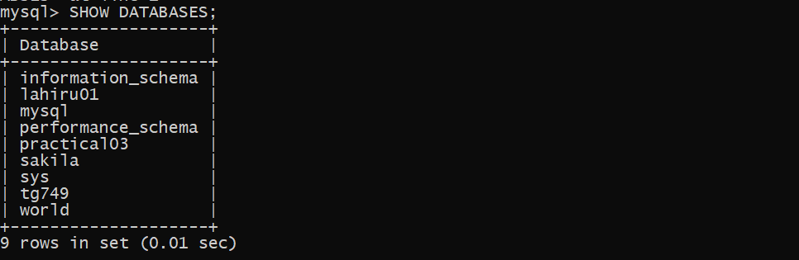



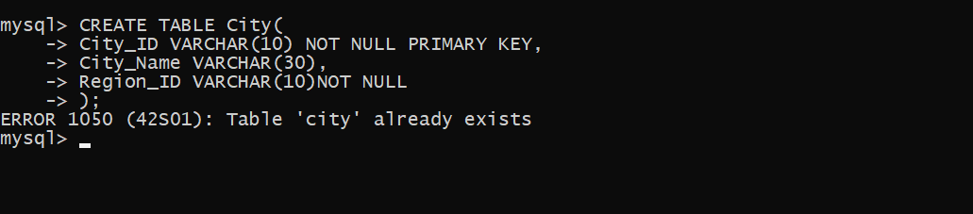



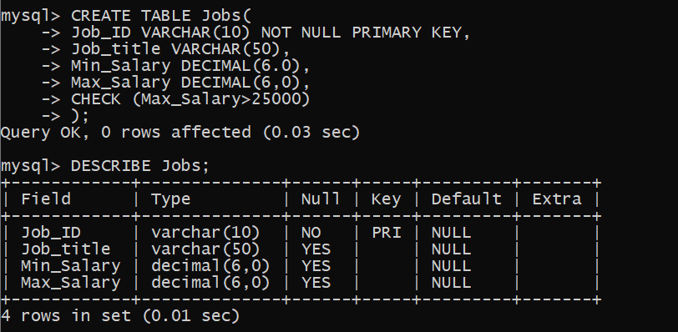

1. 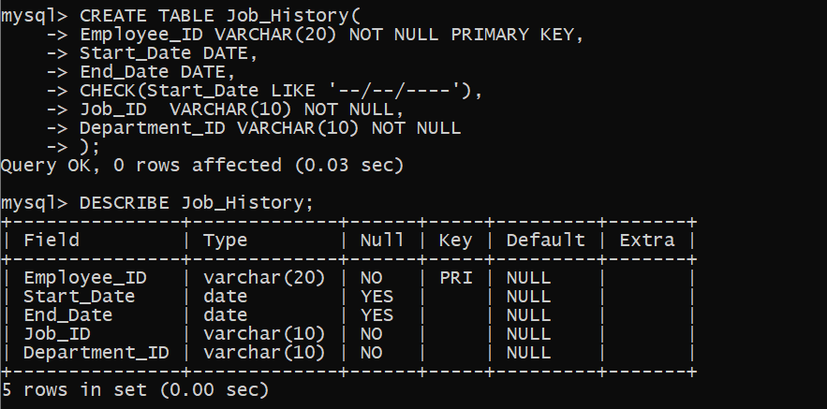

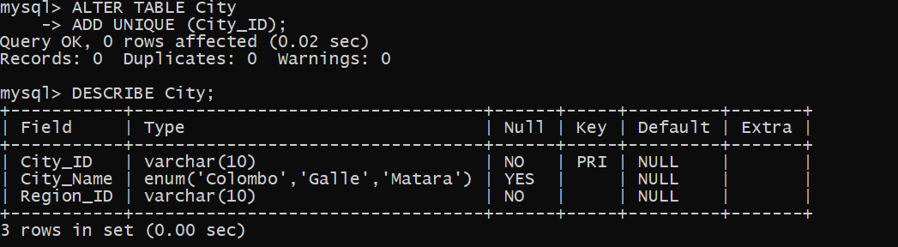

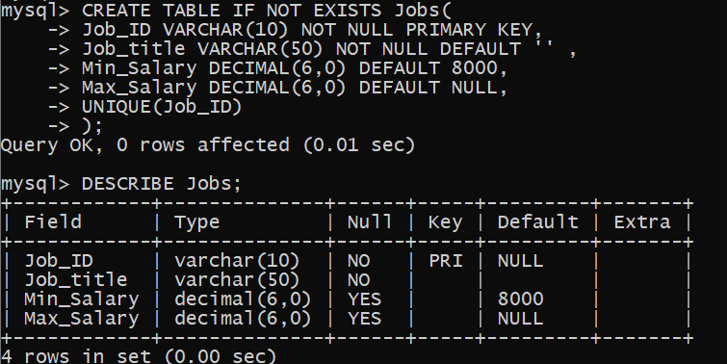

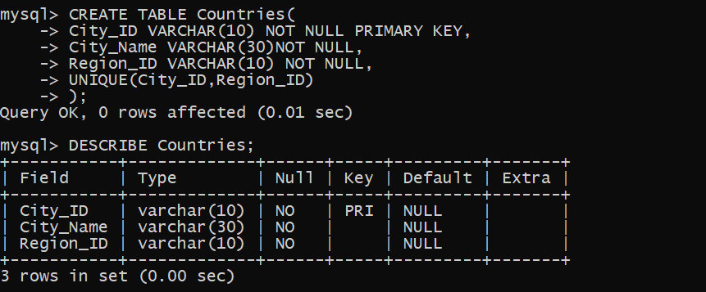

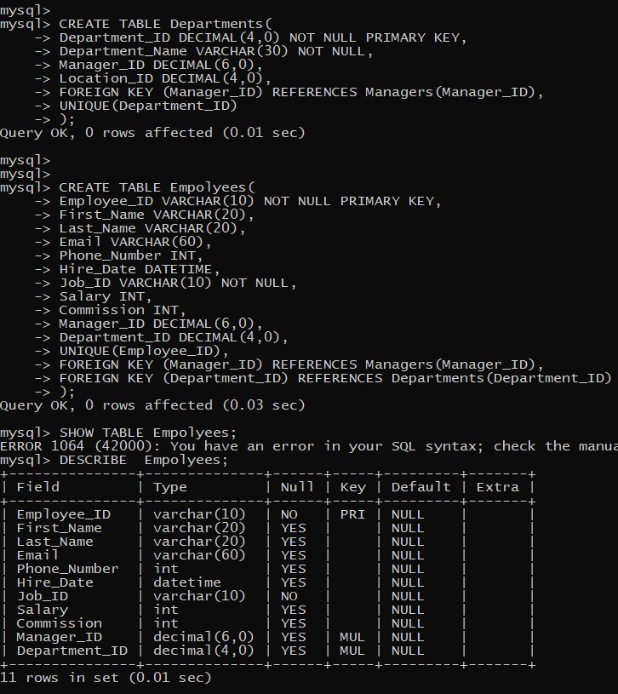

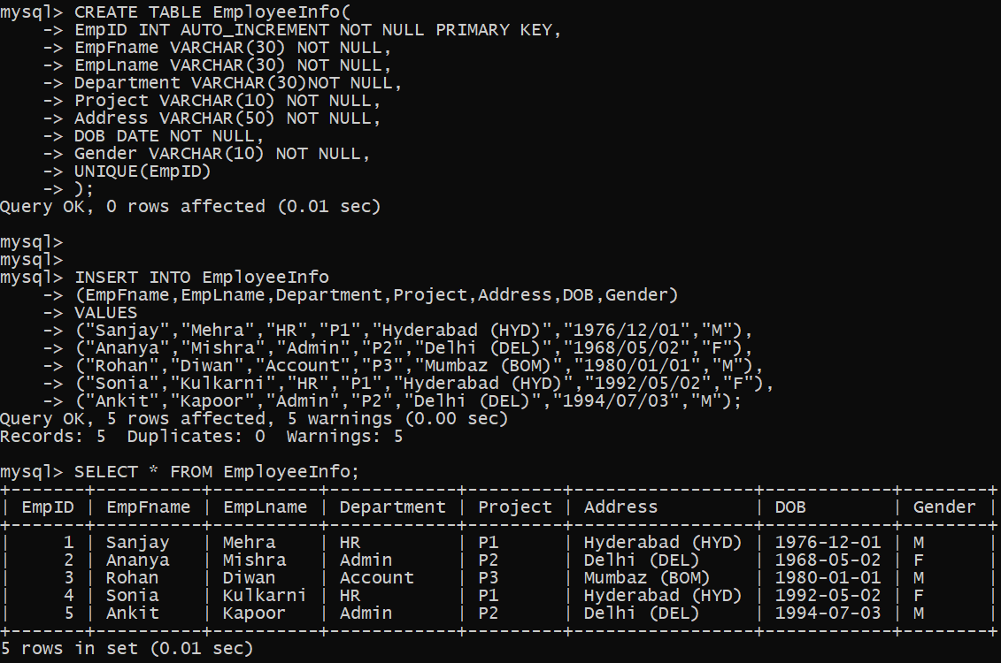

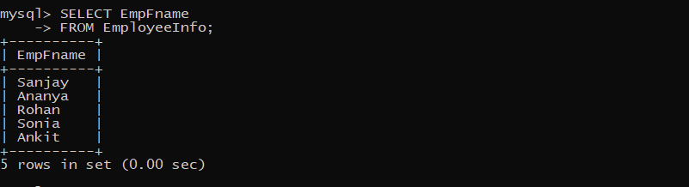

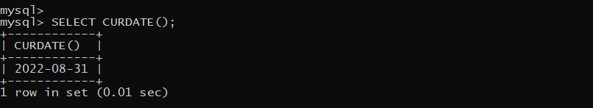

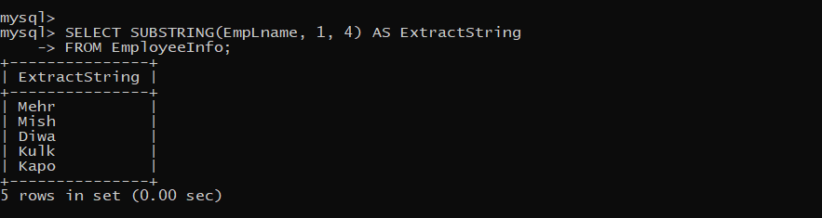

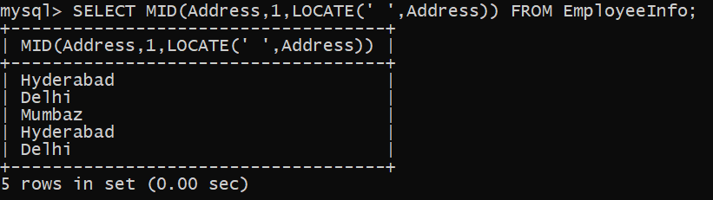

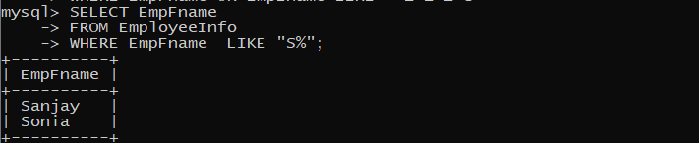

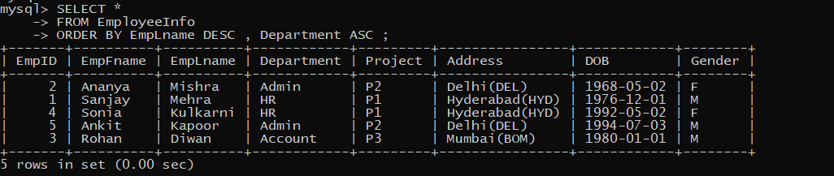

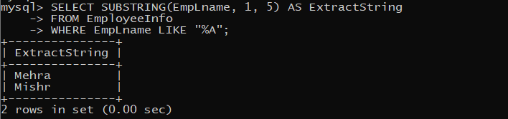

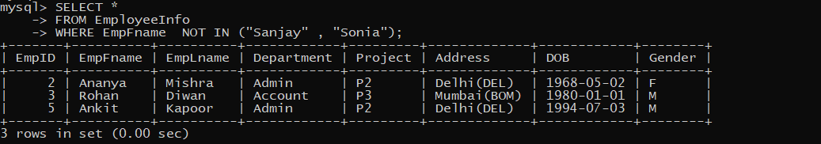

1. 